Feedforward neural network
Data flows in one direction only
- Input layer one or more hidden layers output layer
- Each layer passes its output to the next layer as input

For ex
- Input vector x
- Weight matrix W between input layer and first hidden layer
- Bias vector b
Total input for the next layer / hidden layer
Z=W.x+b
Then , an activation function – like sigmoid, ReLU or tanh – is applied to the value
h = sigma(Z)
here sigma represents the activation function
this output h then becomes input to the next layer
so for each neuron
- Multiply inputs by their weights
- Add a bias term
- Pass the result through an activation function

Above process happens at every layer of the network

Ex
Predicting house prices

Rooms | size | price
3 1340 313000
5 3580 4500399
…..
Prior to training – standardize the data
After standardizing…(substracting mean and dividing by SD)

Rooms | size | price
-0.32 -0.66 -0.54
1.61 1.80 2.03
….
Input layer – 2 inputs (rooms and house size)
Hidden layer – 2 neurons with sigmoid activation
Ouput layer – 1 neuron (regression task)

Feedforward for classification
Ex
Credit card companies may want to classify applicants as
- Good
- Bad
- Needs further analysis
Input features
- Annual income
- Outstanding debts
- Age
- No.of past defaults etc.,

Loss function
Based on above process - can generate predictions, we need a way to measure how accurate they are…..Loss function / Cost function
- It measures how far the network’s predictions are from the actual values

House price ex
Input (rooms, size) predicted price actual price
(-0.32, -0.66) 0.63 -0.54

Loss function quantifies this difference as a single number

For regression problems
MSE – mean squared error
- It squares the diff between predicted and actual values and averages them

For classification
- Cross entropy loss (Log loss)
  - It penalizes incorrect class probabilities

Learning in neural networks?
Learning = adjusting the weights and biases to minimize the loss function
- If loss is high – network predictions are poor – it indicates to update the parameters to improve accuracy
Optimization process ?
- Gradient descent

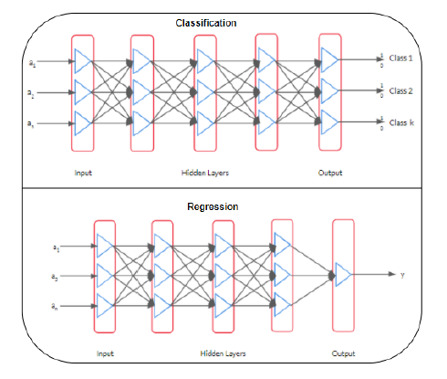
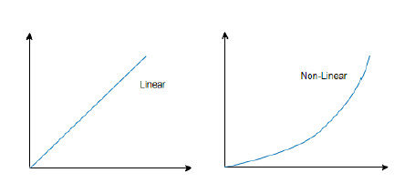

Matrix representation of obtaining z –

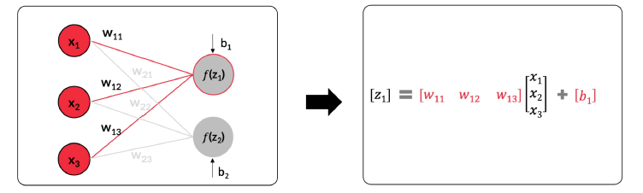

Homogeneous coordinates
Homogeneous coordinates in machine learning are a way to represent geometric transformations like translation, rotation, and scaling as single matrix multiplications.

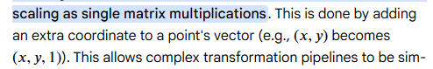

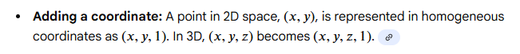

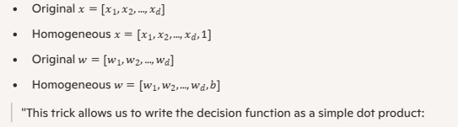

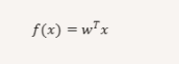

Rosenblatts update rule

Rosenblatt's update rule is the learning algorithm for the perceptron, a single-layer neural network developed in 1958 for binary classification problems. The rule adjusts the perceptron's weights and bias based on misclassified training examples to find an optimal decision boundary.
Understanding perceptron
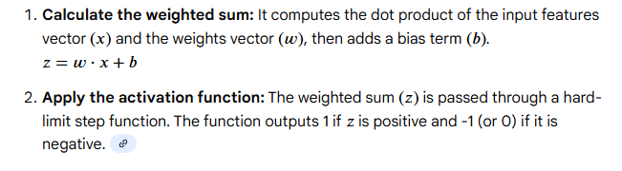

The update rule in action
The update rule modifies the weights and bias only when the perceptron makes an incorrect prediction for a training sample. If a sample is classified correctly, no changes are made.

Let's assume the perceptron outputs 1 or -1. The update logic is as follows:
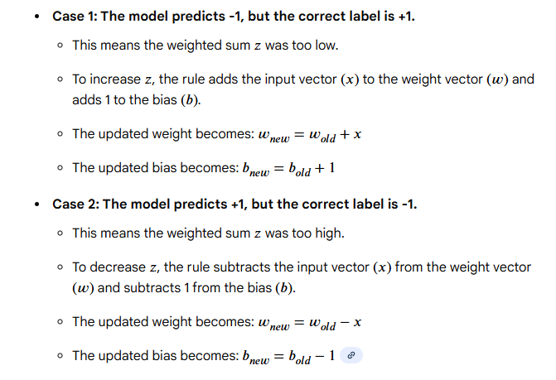

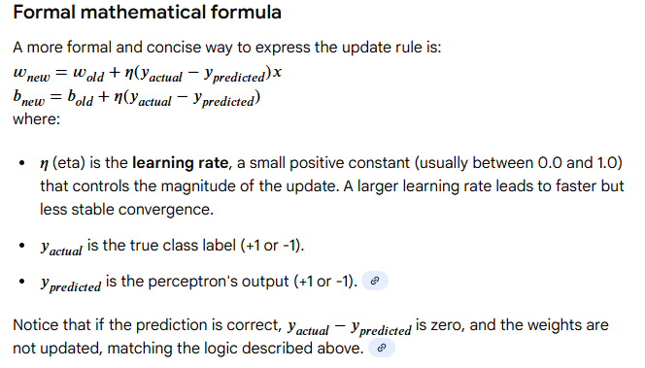

Example
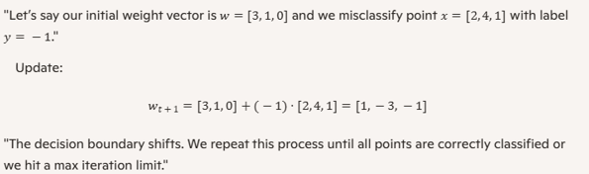

Multiclass classification using perceptrons

Binary classification – a single perceptron ……..
The above works when data is linearly separable

Then what happens when we have more than 2 classes?

Multiclass classification with perceptrons is achieved by extending the binary perceptron to multiple classes using strategies like "one-vs-all" (training multiple binary classifiers, each distinguishing one class from all others) or direct multiclass versions.

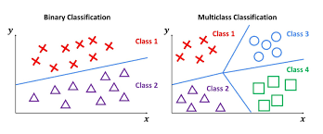

- train one perceptron per class
- each perceptron learn to distinguish its class from others
- for a new input x, compute the activation for each perceptron
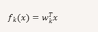
- choose the class with highest activation

Need for backpropagation

- forward propagation gives prediction, but it doesn’t learn by itself
- we need a way to adjust the weights to make predictions closer to the actuals

adjusting weights and biases by knowing how far we are from predictions vs actuals.

Gradient descent
It is the optimization technique to minimize the loss function
Steps
- compute the loss (difference between predicted and actual)
- compute the gradients (how much each weight affects the loss)
- update the weights

formula refer to two scenarios above when to add or when to subtract*
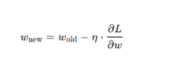

Backpropagation algorithm
- perform forward propagation and compute loss
- compute error at output layer
- propagate the above error at each layer in the network to calculate weights
- update weights using gradient descent

Assignment
Explore other optimization techniques , document and discuss.

